Alexander Baldree
09/19/2026
Module 8.2 Assignment
CSD440

GitHub Link:
https://github.com/Panda-Alex21687/CSD440

Create Table:
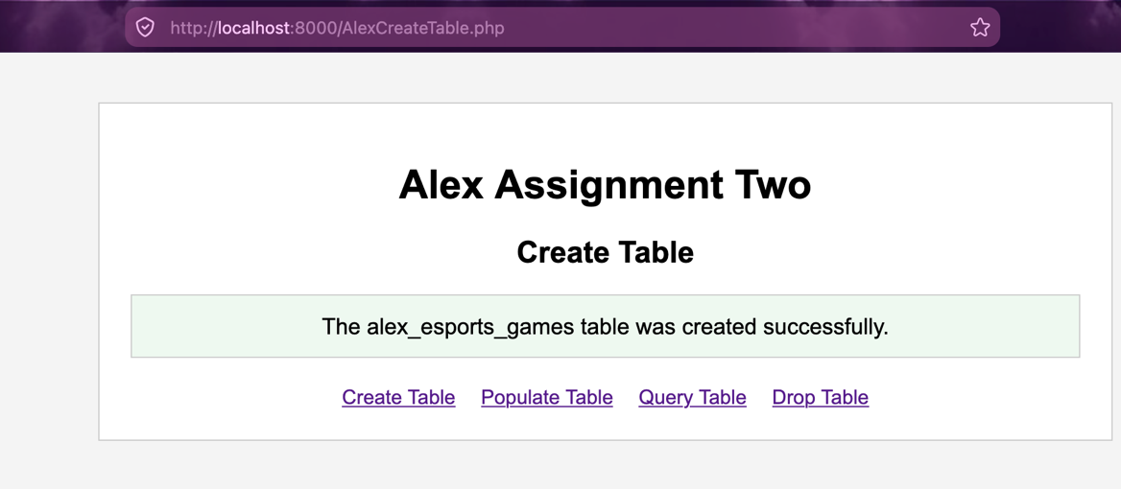

Populate Table:
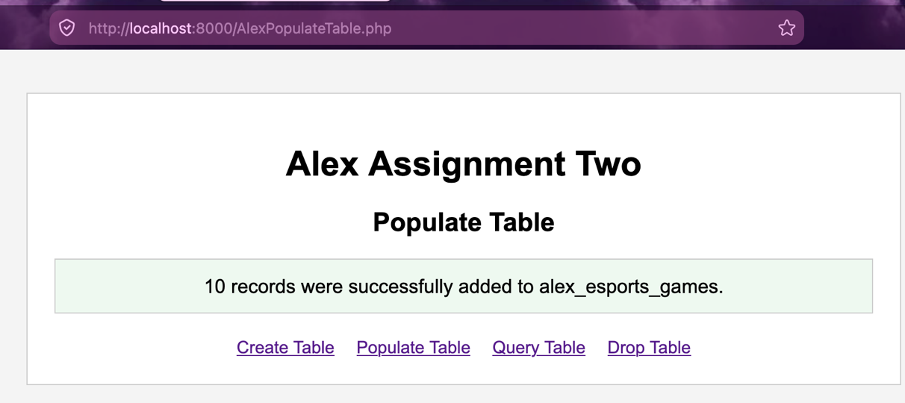
Query Table:
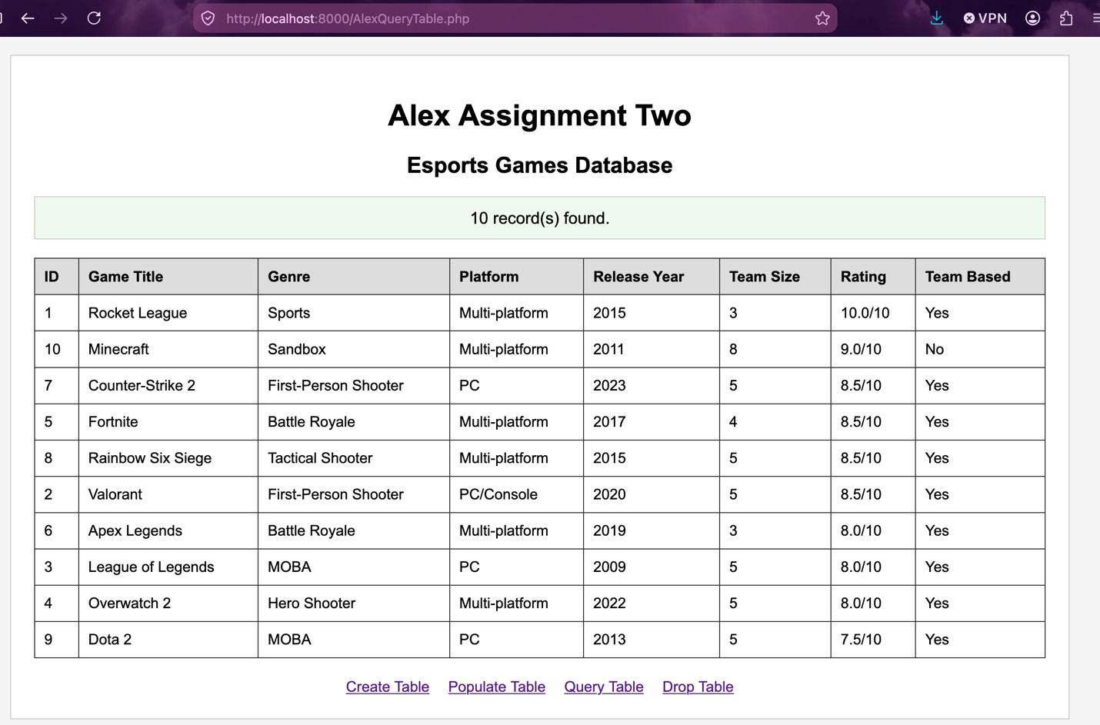

PHPAdmin:
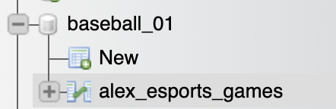
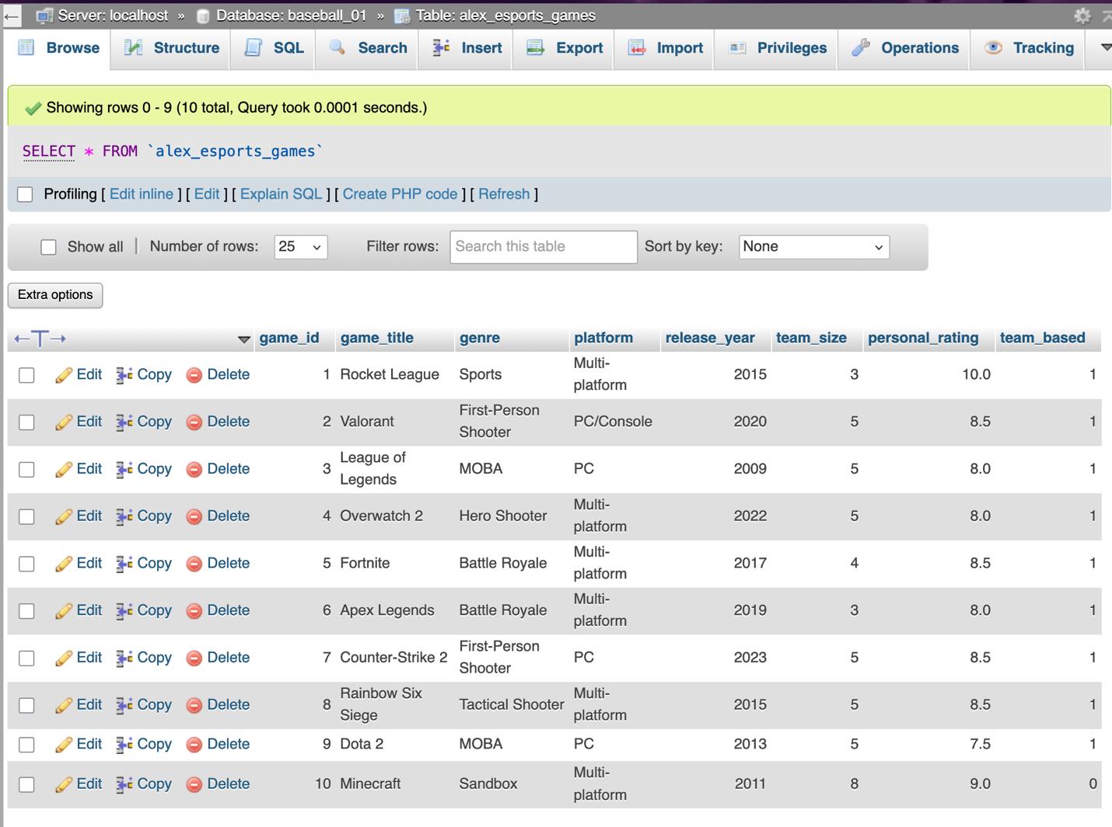

Drop Table:
